**Saint Brigid Saint John the Baptist**

2nd Sunday of Easter

(Sunday of Divine Mercy)

April 8, 2018

**Catholic Church Catholic Church**

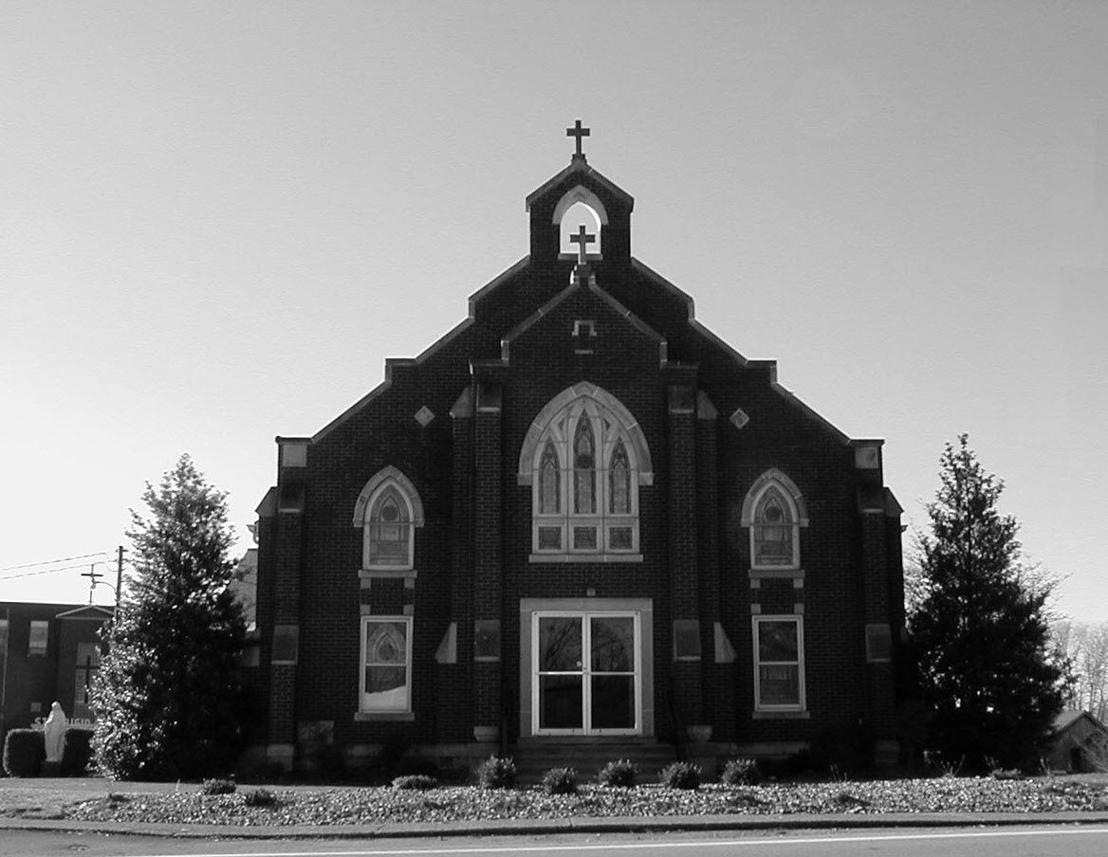

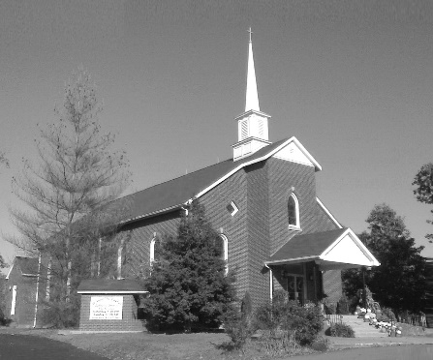

**Pastor:**

***Rev. Daniel L. Lincoln***

Rectory: (270) 877-2546

**Deacon:**

***Michael A. Ryan***

(270) 272-6789

314 E. Main St. 657 St. John Church Rd.

Vine Grove, KY 40175 Elizabethtown, KY 42701

Clustered Parish Office: Clustered Parish Office:

(270) 877-2461 (270) 877-2461

**ANNOINTING OF THE SICK:**

Notify the parish office when a family member is hospitalized.

**BAPTISM:**

Contact the parish office for information about the required preparation class.

**BULLETIN:**

Information must be submitted in writing by note or email to the parish office **no later than 12:00 noon on Wednesdays** for the following weekend. When sending an email, please put “BULLETIN,” and the name of the parish the announcement is for, in the subject line.

**MARRIAGE:**

Contact Father at least 6 months prior to the wedding date to complete required marriage preparations and to schedule the date.

**RCIA (Rite of Christian Initiation of Adults):**

Contact the Worship Chairperson for information.

**DEW MEMORIAL LIBRARY:**

(in St. Brigid Church basement):

Open: Sunday after 9:30 a.m. Mass& 45 minutes before all other Masses.

Email: [brigidvg@bbtel.com](mailto:brigidvg@bbtel.com)

Website:[www.stbrigidvg.org](http://www.stbrigidvg.org)

**Pastoral Associate & Dir. Dir. of Religious Education:**

**of Religious Education:** Lisa Thomas: (270) 735-6930

Deacon Mike Ryan: (270) 877-0546

**Youth Minister: Youth Ministers:**

Lori Law: (270) 723-0157 Angela Churchman:

(270) 268-9963

Ericka Finlay: (502) 612-2644

**MASS SCHEDULE:**

*Sunday:* 9:30 a.m. & 6:30 p.m.

*Monday:* 9:00 a.m.

*Thursday:* 9:00 a.m.

**RECONCILIATION:**

Sunday before Mass

5:30-6:00 p.m. or by appt.

**ROSARY:**

After weekday Masses

**PARISH COUNCIL MEMBERS:**

*President:* Sue Weisshaupt

*Vice-President:* Mike Bramlett

*Secretary:* Judy Cochran

*At-Large Members:* Blake Ryan

& Vincent Thompson

**CHAIRPERSONS:**

*Administration:* Dale Winchester

*Formation:* Tina Yates

*Parish Life:* Tom Billings

*Worship:* Keith Baughman

**MASS SCHEDULE:**

*Saturday (Vigil):*  6:30 p.m.

*Sunday:* 11:30 a.m.

*Wednesday:* 6:30 p.m.

*Friday:* 9:00 a.m.

**RECONCILIATION:**

Saturday before Mass

5:30-6:00p.m. or by appt.

**PARISH COUNCIL MEMBERS:**

*President:* Theresa Smith

*Secretary:* Karen Ray

**CHAIRPERSONS:**

*Administration:* Rick Newton

*Formation:* Ericka Newton

*Parish Life:* Bradley Wickersham

*Worship:* Nick Thomas



**Mass Schedule**

**Mass Schedule**

|  |  |  |  |  |  |
| --- | --- | --- | --- | --- | --- |
| **Saturday** | **April 7** | **6:30 p.m.** | **St. John** | **For All Parishioners** | **Vigil: 2nd Sunday of Easter**  **(or Sunday of Divine Mercy)** |
| **Sunday** | **April 8** | **9:30 a.m.** | **St. Brigid** | **Our Parish Family**  **Clarence “Bud” Brangers** | **2nd Sunday of Easter**  **(or Sunday of Divine Mercy)** |
| **“** | **“** | **11:30 a.m.** | **St. John** | **Bernard Osborne** | **“** |
| **“** | **“** | **6:30 p.m.** | **St. Brigid** | **Billy Cecil** | **“** |
| **Monday** | **April 9** | **9:00 a.m.** | **St. Brigid** | **Dorothy Hulsman**  **Carlos Robbins** | **The Annunciation of the Lord** |
| **Wednesday** | **April 11** | **6:30 p.m.** | **St. John** | **For Special Intentions** | **St. Stanislaus, Bishop & Martyr** |
| **Thursday** | **April 12** | **9:00 a.m.** | **St. Brigid** | **Dickie Cecil**  **Richard Hughes** | **Easter Weekday** |
| **Friday** | **April 13** | **9:00 a.m.** | **St. John** | **In Thanksgiving** | **Easter Weekday** |
| **Saturday** | **April 14** | **6:30 p.m.** | **St. John** | **For Our Military** | **Vigil: 3rd Sunday of Easter** |
| **Sunday** | **April 15** | **9:30 a.m.** | **St. Brigid** | **Our Parish Family**  **Inge Luther, Cameron Ponder & Luise Weisshaupt** | **3rd Sunday of Easter** |
| **“** | **“** | **11:30 a.m.** | **St. John** | **For All Parishioners** | **“** |
| **“** | **“** | **6:30 p.m.** | **St. Brigid** | **James Wm. & Ella**  **Winchester** | **“** |

**INFORMATION FOR BOTH PARISHES**

**HAPPY EASTER!!** May the power of the Resurrection bring you joy, hope and peace throughout this Easter season! Fr. Dan and Deacon Mile.

**THANKS! THANKS!** – My “pacemaker recovery” is over. Thanks for the prayers, cards, meals and rides to and from for the past month. Fr. Dan

**ABORTION AND ADOPTION –** The number of would-be adoptive parents (of newborn babies) far outstrips the supply in America. Each year in the United States, about 135,000 American children are placed for adoption. Experts estimate somewhere between one and two million couples seek to adopt yearly. Every year, there are about 1.3 million abortions. Sadly, only 4% of women with unwanted pregnancies give their children up for adoption. Every child is wanted and wanted desperately! By Pro-Life Articles Author [www.pro-lifearticles.org](http://www.pro-lifearticles.org)

**PROJECT RACHEL** **–** Healing…Forgiveness…Hope…After the experience of an abortion. If you or someone you know is struggling with the pain from an abortion, please consider Project Rachel – a post abortion ministry. To speak to someone confidentially, call (502) 471-2155 or email [ProjectRachel@archlou.org](mailto:ProjectRachel@archlou.org).

**CONFIDENTIAL PREGNANCY AND ADOPTION COUNSELING** – is available at Catholic Charities for women of all ages experiencing untimely pregnancies. A full range of services are provided, including adoptive placement, legal assistance and counseling for individuals, groups and families. Post-abortion counseling is also available. Services are provided regardless of income or marital status. For more information, call Catholic Charities at (502) 637-9786.

**HOLY FAMILY RADIO ON WLCR AM 1040** – Louisville’s only Catholic format radio station, will be hosting their Spring Radiothon, Thursday and Friday, April 12-13. Tune in both days to learn more about how you can help support Catholic Radio in the area! Please consider making a pledge and help our parish be the parish with the most pledges! Call (502) 451-9527 or visit HolyFamilyRadio.org for more information. Listen online at WLCR.org

**SAVE THE DATE** – Fr. John Judie will have a celebration of his retirement, 70th birthday and 31 years of priestly ministry on **Saturday, August 11, 2018**. More details will follow later. He may be reached at (502) 774-5772.

. * * * * * * * * * * * * * * * * * * *

**St. John and St. Brigid Prayer List**

To add someone to the prayer list, please call the parish office at (270) 877-2461. **Remember to call to remove someone from the list if they are no longer sick, etc.** *Please note that the prayer list has been revised. It is primarily for parishioners and their immediate family members*.

Helen “Dinky” (Cowley) **Adams**, Sam **Adams**, April **Allen**, Dennis **Arnold**, Barbara **Ashley**, Donnie Alan **Atcher**, Sue **Banks**, Shannon **Barnes,** Denise **Barnett**, the **Bigler** family, Timothy **Birch**, Teresa **Laycock**, Charlie **Bowers**, Pauline **Brangers**, Wanda **Branson**, Bill **Brown**, Ellen **Bryan**, Richard **Bryson**, Carol **Buchanan**, Jeremy & Margie **Buyer**, Ashley **Butler**, Deacon Bob **Caspar**, Sue **Caswell**, Ed **Cecil**, J. Mack **Cecil**, Harlan Ford **Clark**, John **Connor**, Betty Jo **Cooper**, Heidi **Correa**, Jeff **Craig**, Glynn **Clutches**, Roan **Dowell**, Karen **Dworshak**, Leroy **Embry**, Martha **Ford**, Dwayne **Garcia**, Carrie **Gribben**, Mary **Hager**, Mrs. Charles **Hair**, Stephanie **Hall**, Donnie **Hart**, Jimmy **Harper**, Bobby **Harris**, Debbie **Hodge**, Betty Lou **Jones**, Andrew **Kieta**, Jenny **Leonhardt**, Jackie **Long**, Louise **Lucous**, Alma **Mahanna**, Shelly **Martin**, Shirley **Martin**, Martina **Masoni**, Don **Mattingly**, Paul Michael **Mattingly**, Mary **Medley,** Cindy **Miller**, Starla **Miller**, Doug **Osborne**, Bernard **Osborne**, Duane **Osborne**, Mickey **Padgett**, Frank **Inanely**, Polly **Prather**, Annie **Pierce**, Adrianna **Porter**, Jeremy **Porter**, Adrian **Ray**, Allie **Ray**, Mary Agnes **Ray**, Mary Ellen **Ray**, James S. **Reed**, Sharon **Reed**, Tonya **Reisinger**, Joel **Rivera**, Caroline **Seabee**, Darlene **Staples**, Ralph **Staples**, Joan **Stith**, Keith **Tassin**, Kenny **Thompson**, Charles **Tucker,** Raffaella **Tucker**, Debi **Turner**, Charlotte **Vowels**, Bill **Waldrop**, Lois **Weaver**, Paul A. **Whelan**, Jennifer **Williams**, Sandy **Wiseman**, Zach **Wiseman**, Gail **Wilson**, Don **Wooldridge**, Connor **Wright**, Rose Marie **Yates** and all the sick.

* * * * * * * * * * * * * * * * * * *

**Our Military List**

To add someone to the military list, please call the parish office at (270) 877-2461. **Remember to call to remove someone from the list if they are no longer in the service**.

Lt. Matt **Bednar**, PFC Richard H. **Chapman**, A1C Brandon **Davila**, SrA Felicia **Esquivel**, PFC Tyler **Hall**, A1C Ryan **Henley**, A1C Joseph **Manco**, SPC Jacob L. **Nall**, SFC Peter **Novak**, Tony **Rickerl**, Lt. Col. Paul **Rigby**, James **Rogers**, Tony **Rogers**, Jonathon **Sifford**, Jeffrey **Slade**, Derek **Smith**, CSM Vance **Snider**, Brian **Tomassi**, A1C Daniel **Trombone**, SGT Evan **Vaughan**, Lisa **Flynn-Veri**, LT Michael **Veri**, LTC Steve **Wickersham**, SGT Clay **Wilson**, TSGT Jeremy **Yates**, Austin **Zulka** and for all who serve and have served our country.

* * * * * * * * * * * * * * * * * * *

**ST. JOHN THE BAPTIST CATHOLIC CHURCH INFORMATION**

**Monthly Budget Amount Needed:** $ 12,500.00

**Monthly Collection for March:** $ 12,243.30

**Monthly Collection for April:** $ 3,200.00

**WELCOME PACKETS** – If you would like to become a member, or learn more about St. John Parish, please take a *Welcome Packet* in the church lobby. You may return the census card and the stewardship form to Father Dan or place in the collection basket.

**FISH FRY** – Thanks for supporting our Lenten Fish Fry! $5,735.89 was donated to the Rineyville Community Park!

**FRIDAY MASSES** – The 9:00 a.m. Mass at St. John will resume on **April 6**.

**PARISH DISCERNMENT** – The CORE TEAM members are: Lisa Thomas, Clarissa Yates, Ericka Finlay, Karen Ray, Rick Newton and Rhonda Newton.

**YOUTH GROUP BLESSING BAGS** – The youth have determined their service project for the Spring and we are asking for the help of the Parish in getting this off the ground! We will be putting together Blessing Bags to distribute to the homeless in our local communities. We are asking for donations of the following items to go in a gallon size Ziploc bag: Toothpaste (travel size), Toothbrush, Mouth Wash (travel size), Kleenex, Gum, Granola bars, Socks, Face Wipes (travel size/individual packages), Hand Sanitizer (travel size), Lotion (travel size), Crackers (individually wrapped), Comb/Brush (travel size), Chapstick, and Deodorant (travel size). There will be a box in the lobby of the Church for you to donate your items. We will be putting these bags together on **April 8** and will be distributing bags after that. Thank you for any and all donations/help. It is very much appreciated! God bless you. Angela Churchman

**SAFE ENVIRONMENT TRAINING –** A Safe Environment Training workshop will be held at St. James Church Elizabethtown, in Batcheldor Hall on **Thursday, April 19, at 6:30 p.m.**  No pre-registration required.  Anyone over 18 who volunteers with our youth or any at risk individuals must attend this training one time.  This includes all VBS volunteers, RE teachers and volunteers, etc...  Please be sure to sign and in and return your completed form to Lisa Thomas at St. John.  Any questions please contact Lisa at 270-735-6930 or [glalt@comcast.net](mailto:glalt@comcast.net).

**PARISH COUNCIL** – will meet on **Monday, April 23, at 6:30 p.m.**

**FR. STAN OSBORNE** – can be reached at Nazareth Home, Room 112, 2000 Newburg Rd., Louisville, KY 40205.

* * * * * * * * * * * * * * * * * * *

**St. John Liturgical Ministers**

|  |  |
| --- | --- |
| **Vigil: 3rd Sunday of Easter, April 14, 2018, 6:30 p.m.** |  |
| Extraordinary Ministers of the Eucharist | Marcella Crewz Becky Thomas Dennis Thomas |
| Lector | Tony Smith |
| Servers | Katie French Volunteer |
| Greeter(s) | Rhonda Newton |
| Gift Bearers | Newton Family |
| - Ushers | John Thomas Kenny Heibert |
| **3rd Sunday of Easter, April 15, 2018, 11:30 a.m.** |  |
| Extraordinary Ministers of the Eucharist | Lisa Parrett Doug & Shonda Leasor |
| Lector | Gary Brangers |
| Servers | Caia Goode Faith Ramos |
| Greeter(s) | Jennifer Updegraff |
| Gift Bearers | Martha Thomas Family |
| Ushers | Kenny Leasor Doug Updegraff |
| **Hospital Ministry – Sunday, April 22, 2018** | Marcella Brangers |

**Religious Education**

**Classes resume on April 8.** First Communion to be celebrated on **April 22 at the 11:30 a.m. Mass**. Please keep these children, and their families, in your prayers as they complete their preparation for this Sacrament.  **Our final class for the year will be on April 29.**  As we wind our year down to a close, we encourage everyone to keep their commitment to their Religious Education by attending these final classes and by continuing to attend Mass regularly during the Summer months.  Remember the word Catholic means Universal. You can always find a Mass to attend.

* * * * * * * * * * * * * * * * * * *

**ST. BRIGID CATHOLIC CHURCH NFORMATION**

**Monthly Budget Amount Needed:** $ 25,280.00

**Monthly Collection for March:** $ 30,707.00

**Monthly Collection for April:** $ 9,088.00

**WELCOME VISITORS** – If you are interested in joining our parish, please pick up a Welcome Packet at the church doors. Complete the registration form and either drop it in the collection basket or mail it to the office. If you just need to update your registration, there are also forms available.

**WELCOME** – to the newest arrivals to our church family who will receive 1st Communion and Confirmation at the Easter Vigil: Crystal Yates, Emily Bohannon and John Williams.

**FRIDAY MASSES** – The 9:00 a.m. Mass at St. John will resume on **April 6**.

**PARISH DISCERNMENT** – The CORE TEAM members are: Nannette Johnston, Judy Cochran, Blake Ryan, John Jenkins, Suzanne Weisshaupt and John Tindall.

**HOSPITAL MINISTRY** – The parish needs more volunteers to assist with taking communion to those who are in the hospital. You would serve one time a month, three times a year of less depending on the number of volunteers we have. Your service is greatly needed and appreciated. Call the Parish Office if you can help.

**SUMMER EVENT ENVELOPE** – Please turn in your Summer Event offering envelope. It should have been in your March envelopes. This helps us pay for the printing of the Summer Event tickets and the dinner tickets and a few other things. Should you have any questions, please contact Deacon Mike.

**PARISH COUNCIL** – will meet on **Thursday, April 19, at 7:00 p.m.**

**BLOOD DRIVE** – The next drive will be held on **Friday, April 20,** from 10:00 a.m.-2:00 p.m. in the CCC building. Give the gift of life!! This is more rewarding than what else you have to do today!!

**COMMUNION MINISTER UPDATE SESSIONS** – are for those ministers needing a mandate renewal, who have already completed the archdiocesan two-session Communion Minister Formation Program. This session will fulfill the requirements for continuing formation for Extraordinary Ministers of Holy Communion. I have scheduled the mandatory update session for **September 27, 2018 from 7:00- 9:00 p.m.** Please add to your calendar. I will put the form applications out three weeks before and make sure a new announcement gets into the bulletin. Should you have questions please contact Deacon Mike.

* * * * * * * * * * * * * * * * * * *

**St. Brigid Youth Ministry**

If you have any questions, please contact Lori at (270) 723-0157 or email at [stbrigidyouth@hotmail.com](mailto:stbrigidyouth@hotmail.com).

* * * * * * * * * * * * * * * * * * *

**St. Brigid Liturgical Ministers**

|  |  |
| --- | --- |
| **3rd Sunday of Easter, April 15, 2018, 9:30 a.m.** |  |
| Extraordinary Ministers of the Eucharist P. | Jim Klimesh Janey Jenkins |
| C. | E, Jane Vessels David Stoddard Sherleen Barren |
| Lector | Karen Harris |
| Servers | Maggie Board Alexander Lozano |
| Greeters | Charles & Pam DeRoche Volunteer |
| **3rd Sunday of Easter, April 15, 2018, 6:30 p.m.** |  |
| Extraordinary Ministers of the Eucharist P. | Kim Osterhage |
| C. | Ashley Osterhage |
| Lector | Ashley Osterhage |
| Servers | Volunteers |
| Greeters | Volunteers |
| **Hospital Ministry – Sunday, May 20, 2018** | James & Julie Weed |

**St. Brigid Monthly Meet and Greet**

St. Brigid Parish hosts a “Meet and Greet” downstairs the 2nd Sunday of each month immediately following the 9:30 a.m. Mass with coffee and donuts. This is a great opportunity for existing parishioners to extend a warm welcome to visitors and anyone interested in joining St. Brigid Parish. Be sure to also visit the Dew Memorial Library.

**The next Meet and Greet will be Sunday, April 8, 2018.**

***Marriage Moments*** –

*“Whoever fails to love does not know God, because God is love.”*  1 John 4:8

Do you know anyone who claims to love God yet does not act lovingly toward a family member they have hurt, a neighbor, creation? Don’t let it be you.

***Parenting Pointers*** –

*“Whose sins you forgive are forgiven them.”* John 20:23

Confession need not be limited to a priest in the confessional. Confess a mistake you’ve made to your child. Is there anyone and can ask forgiveness from? Especially consider siblings.



*“…he showed them his hands and his side.”*